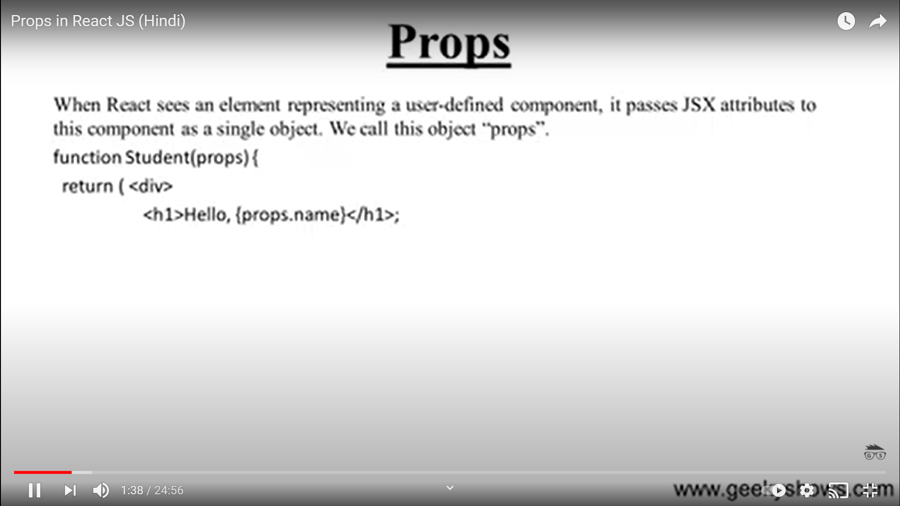

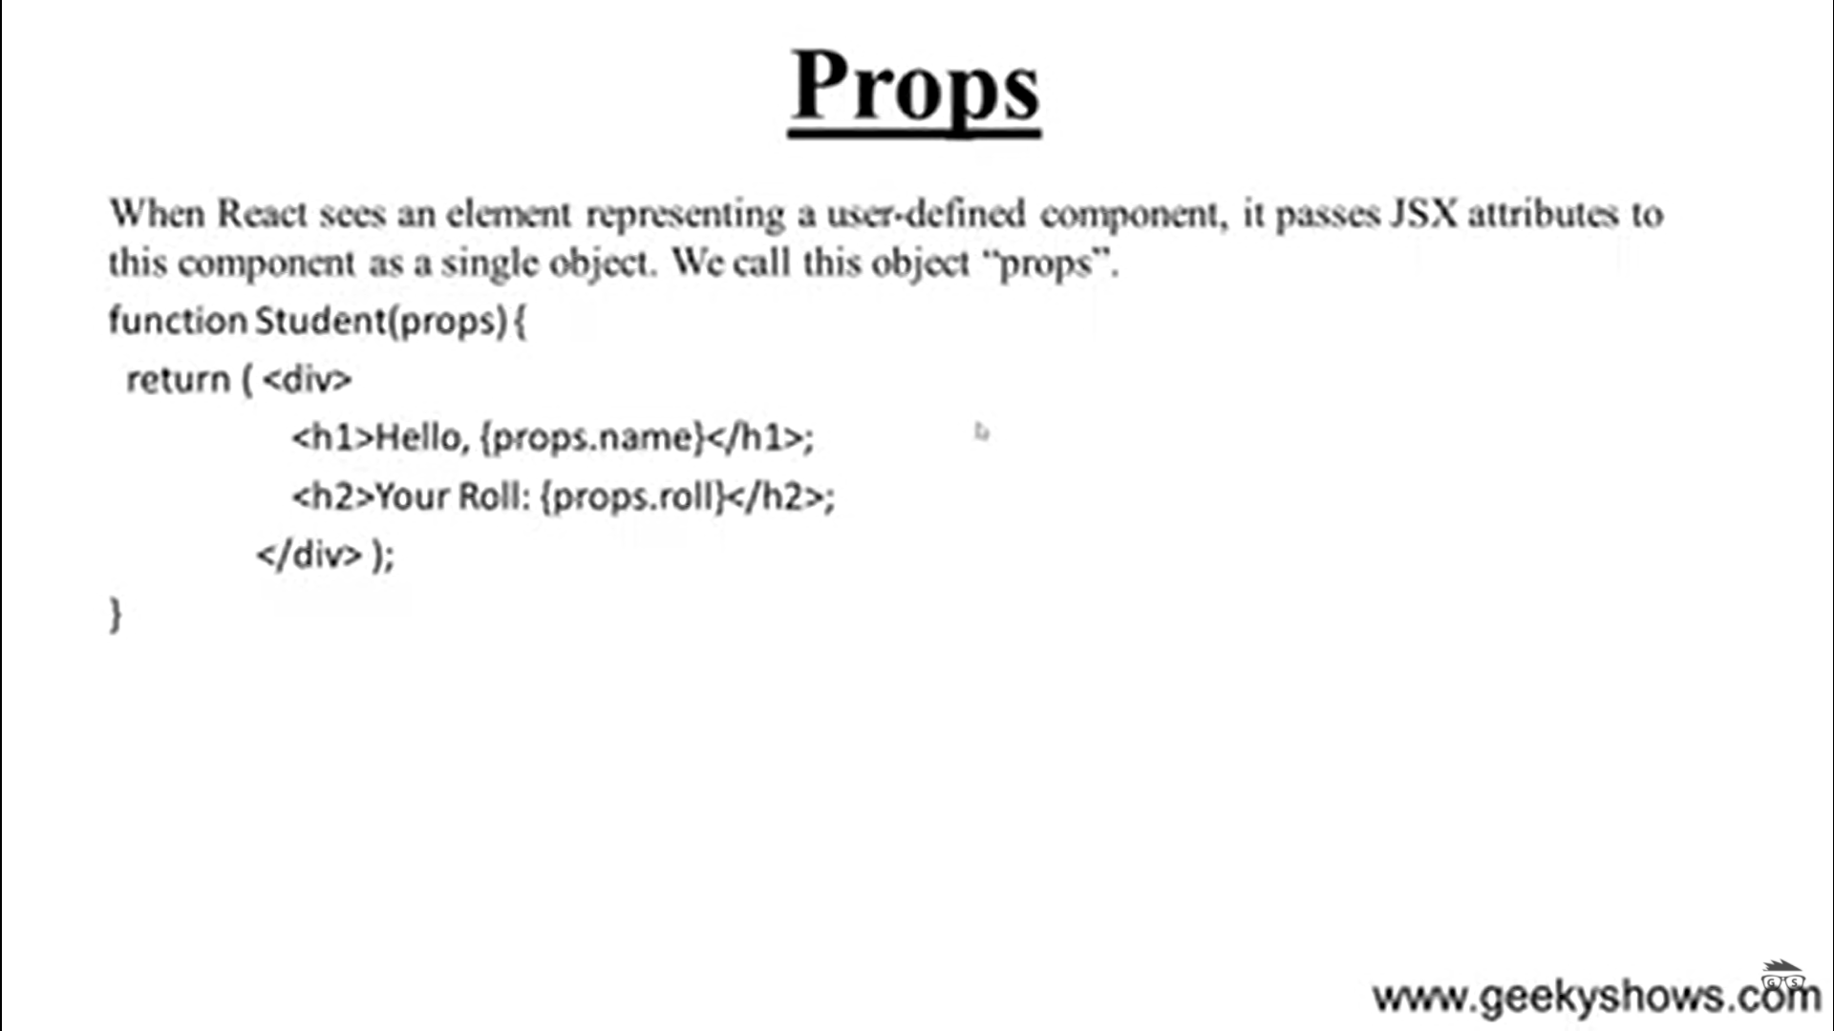

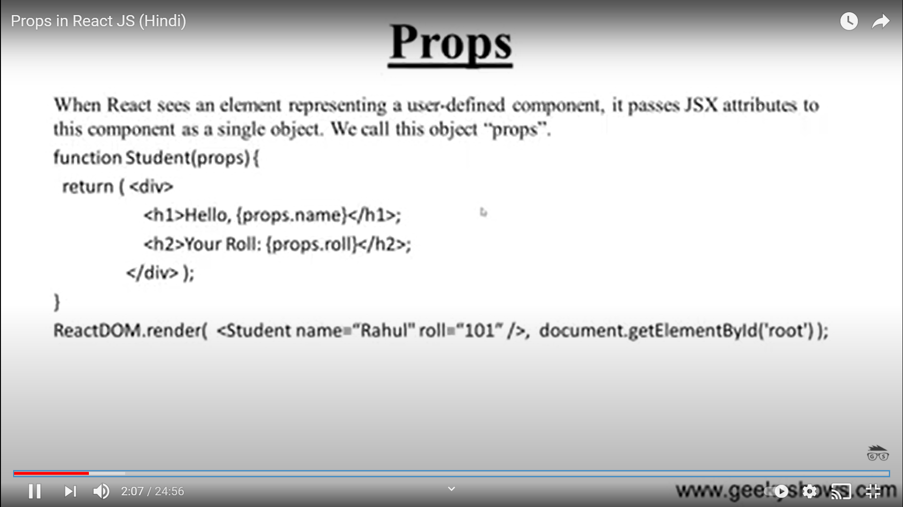

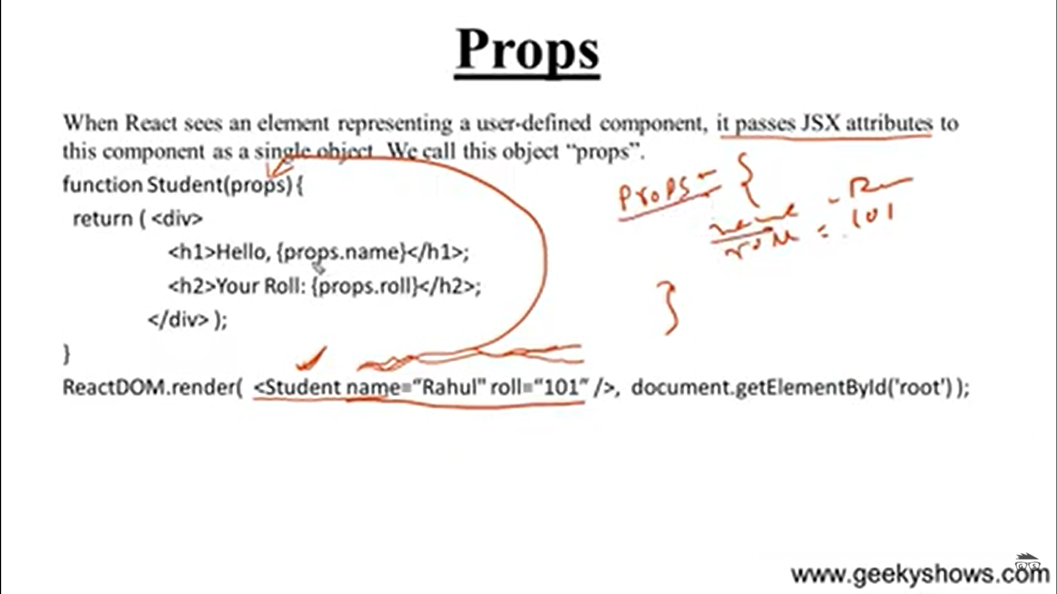

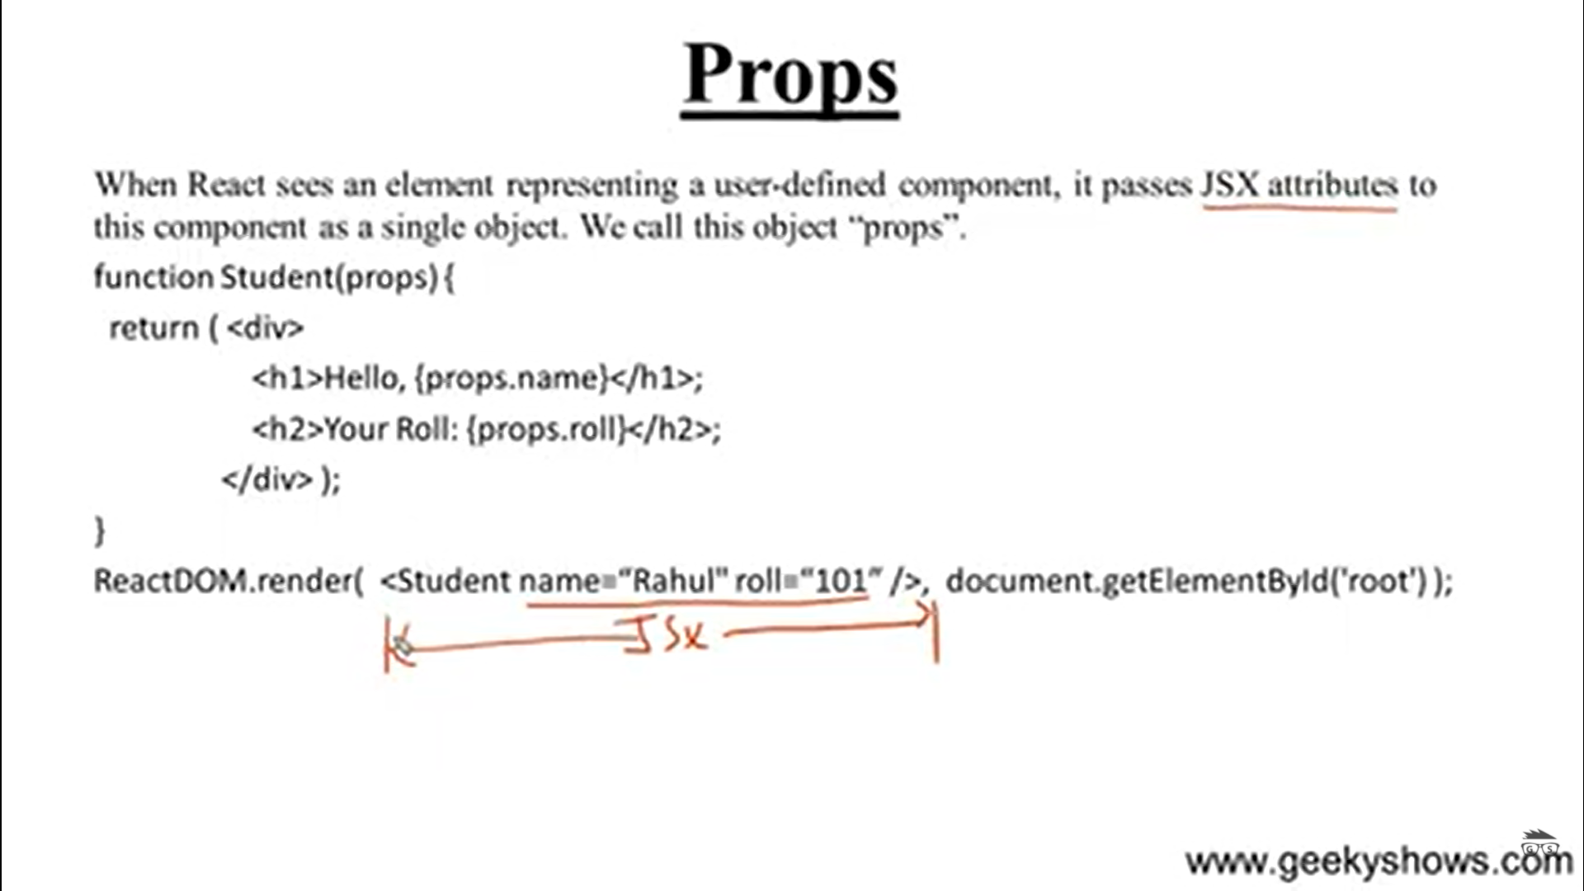

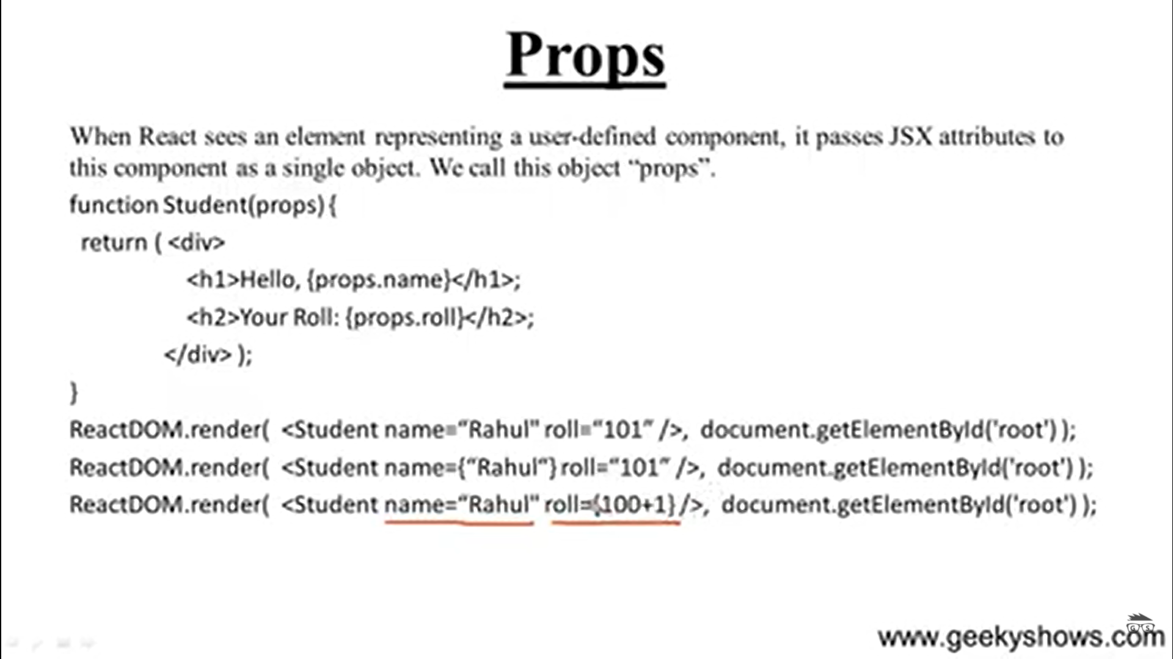

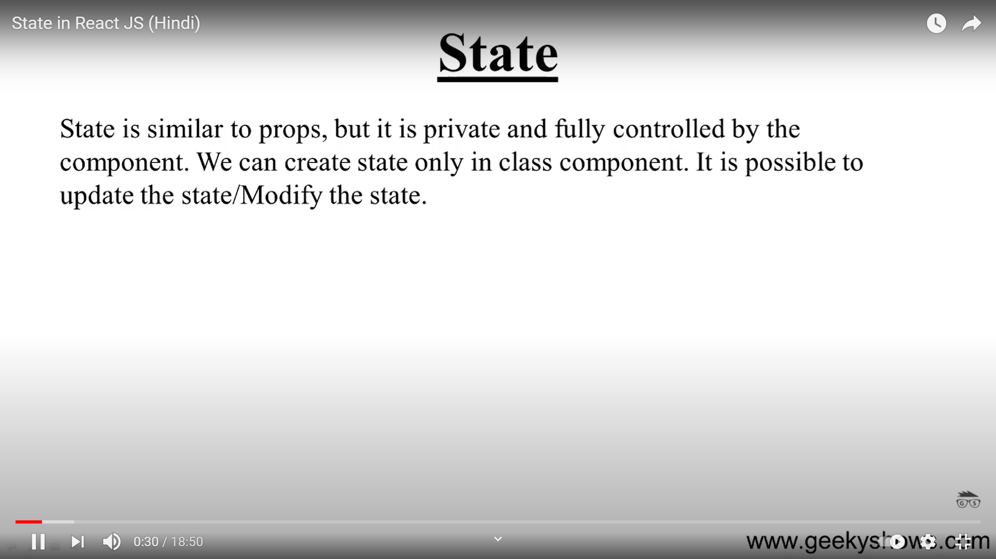

State is private

It can be modified

It can be used only in class component

If you want to have any data which can be modified

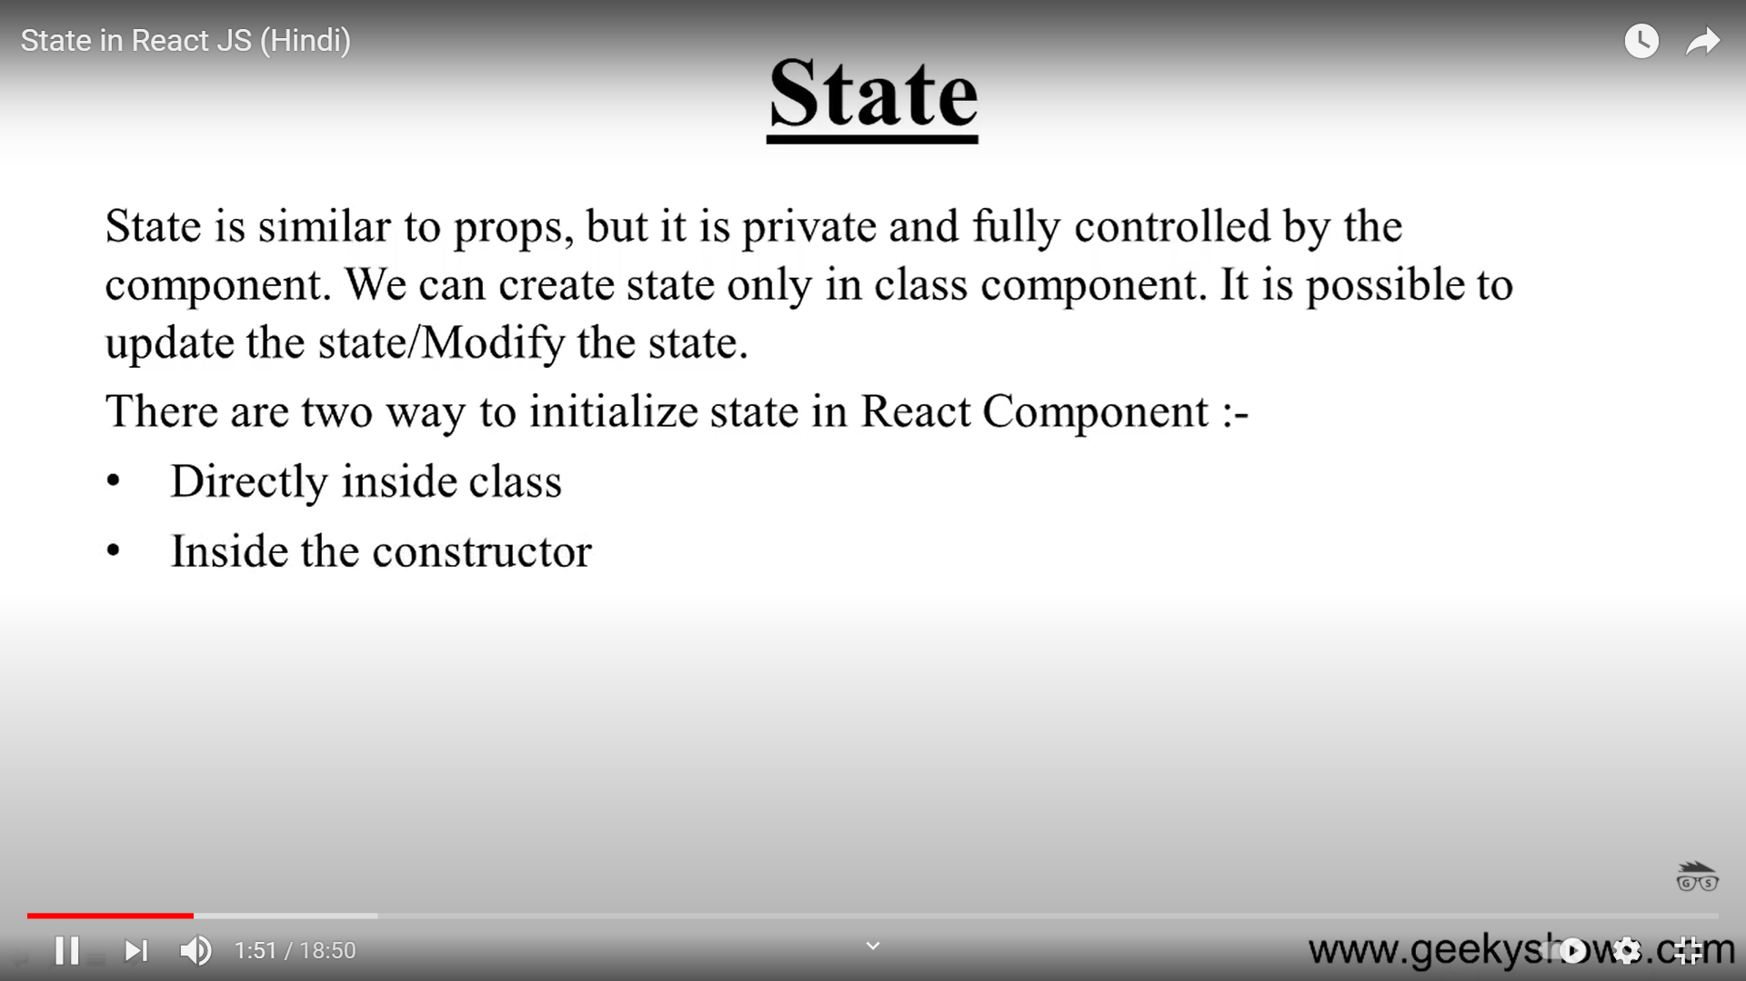

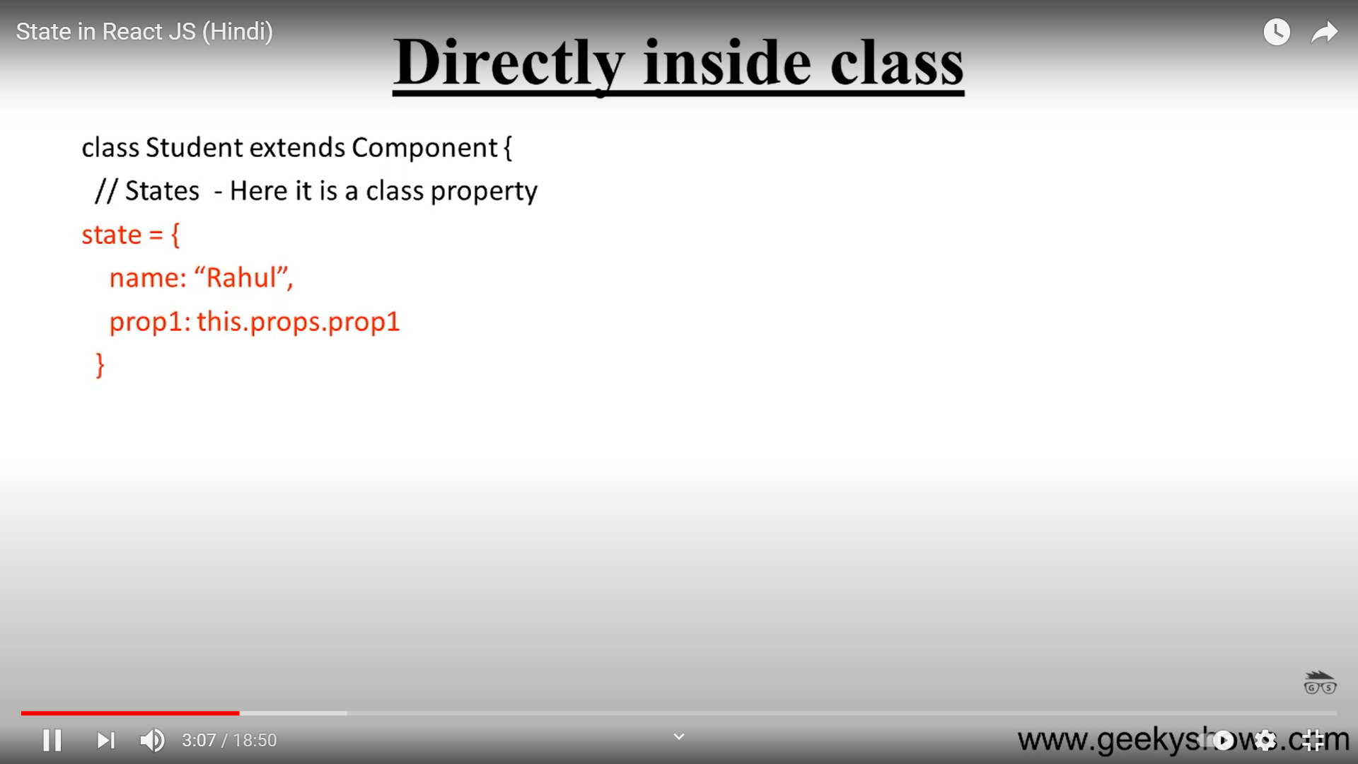

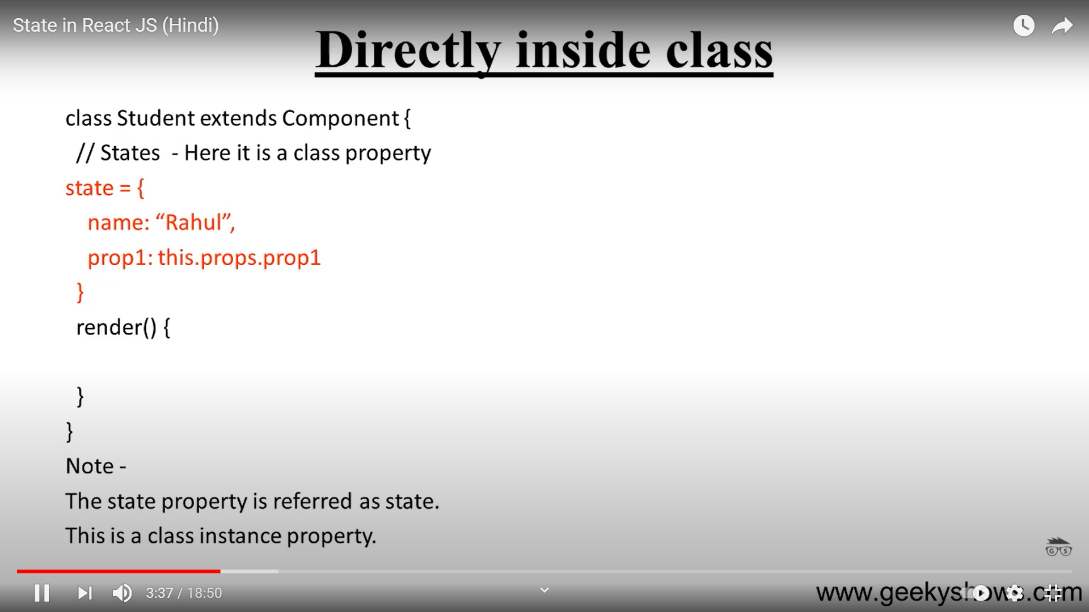

Install ES7 React/Redux/GraphQL/React-N Extnesion

Imrc

import React, { Component } from 'react'

state inside Inside constructor

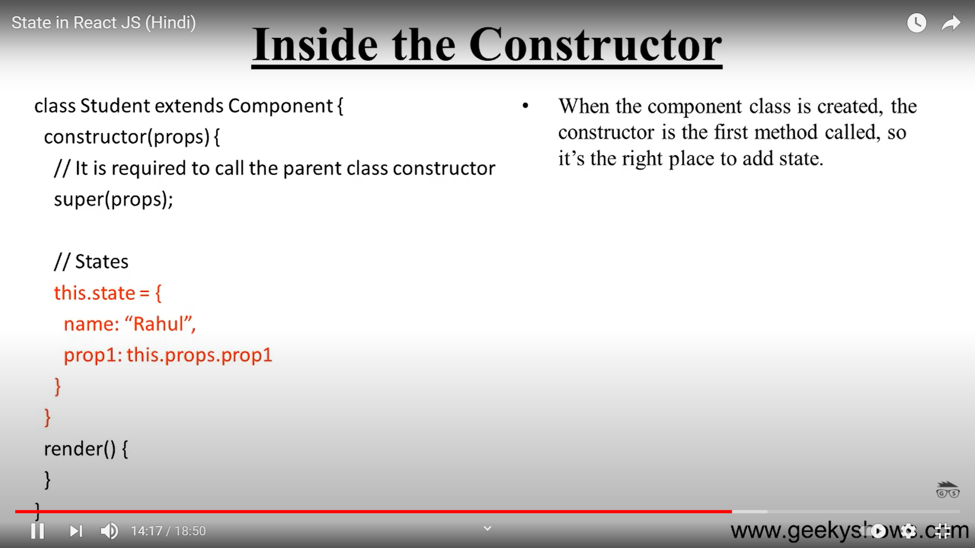

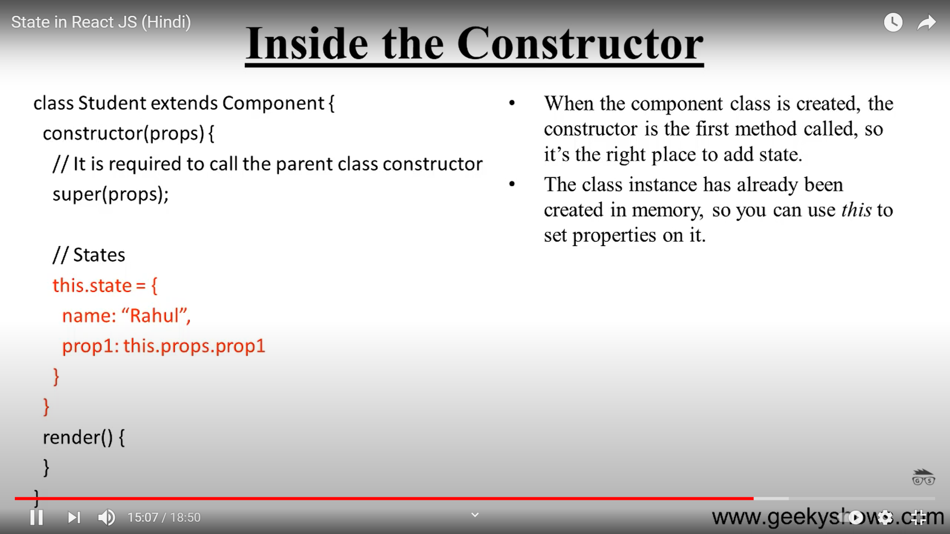

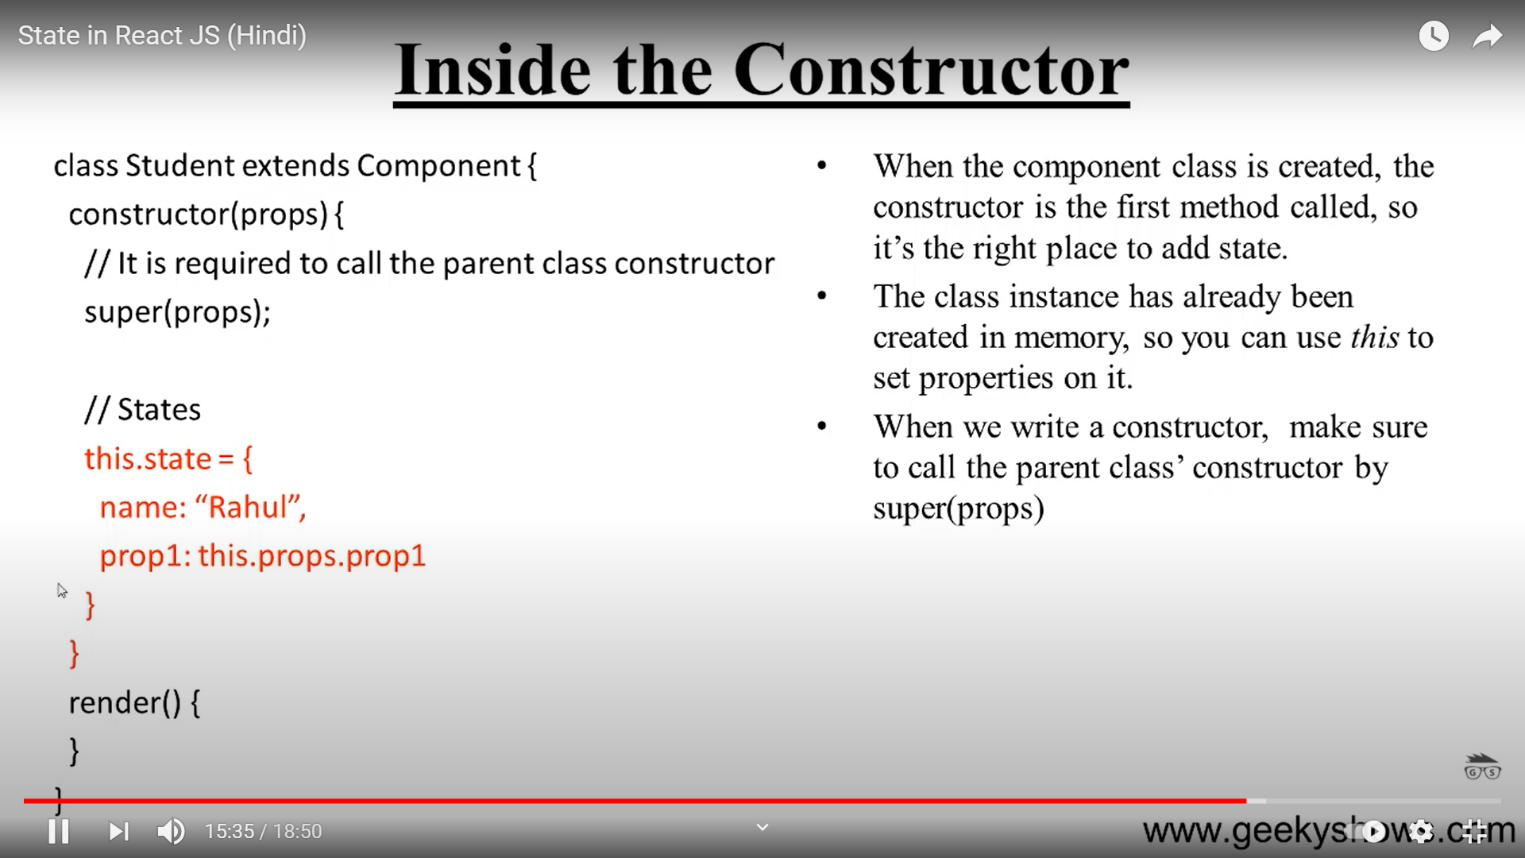

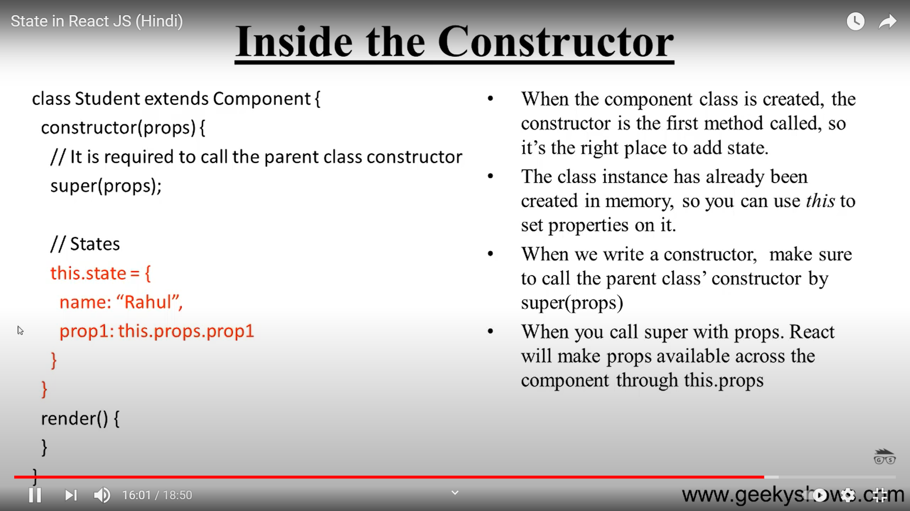

Update State

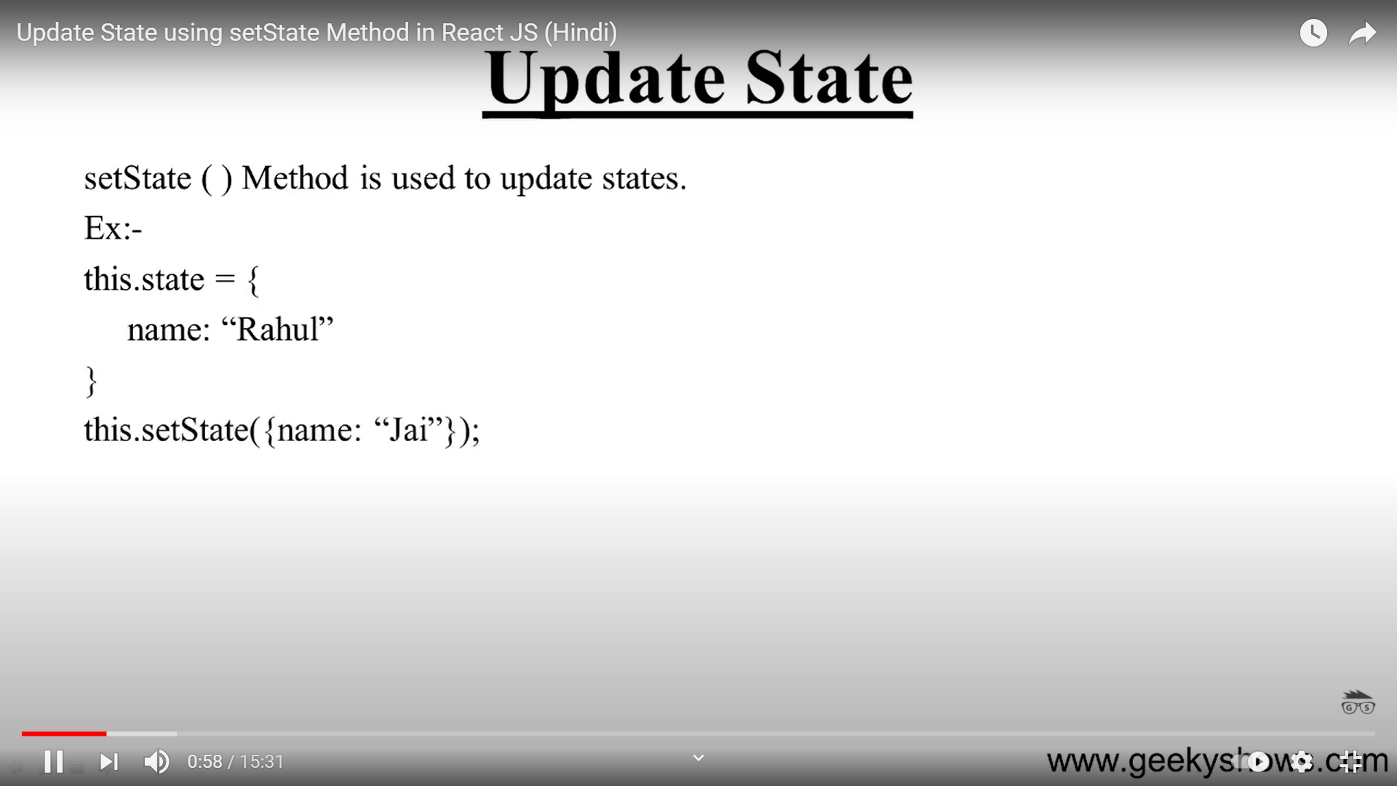

We will change state on an event

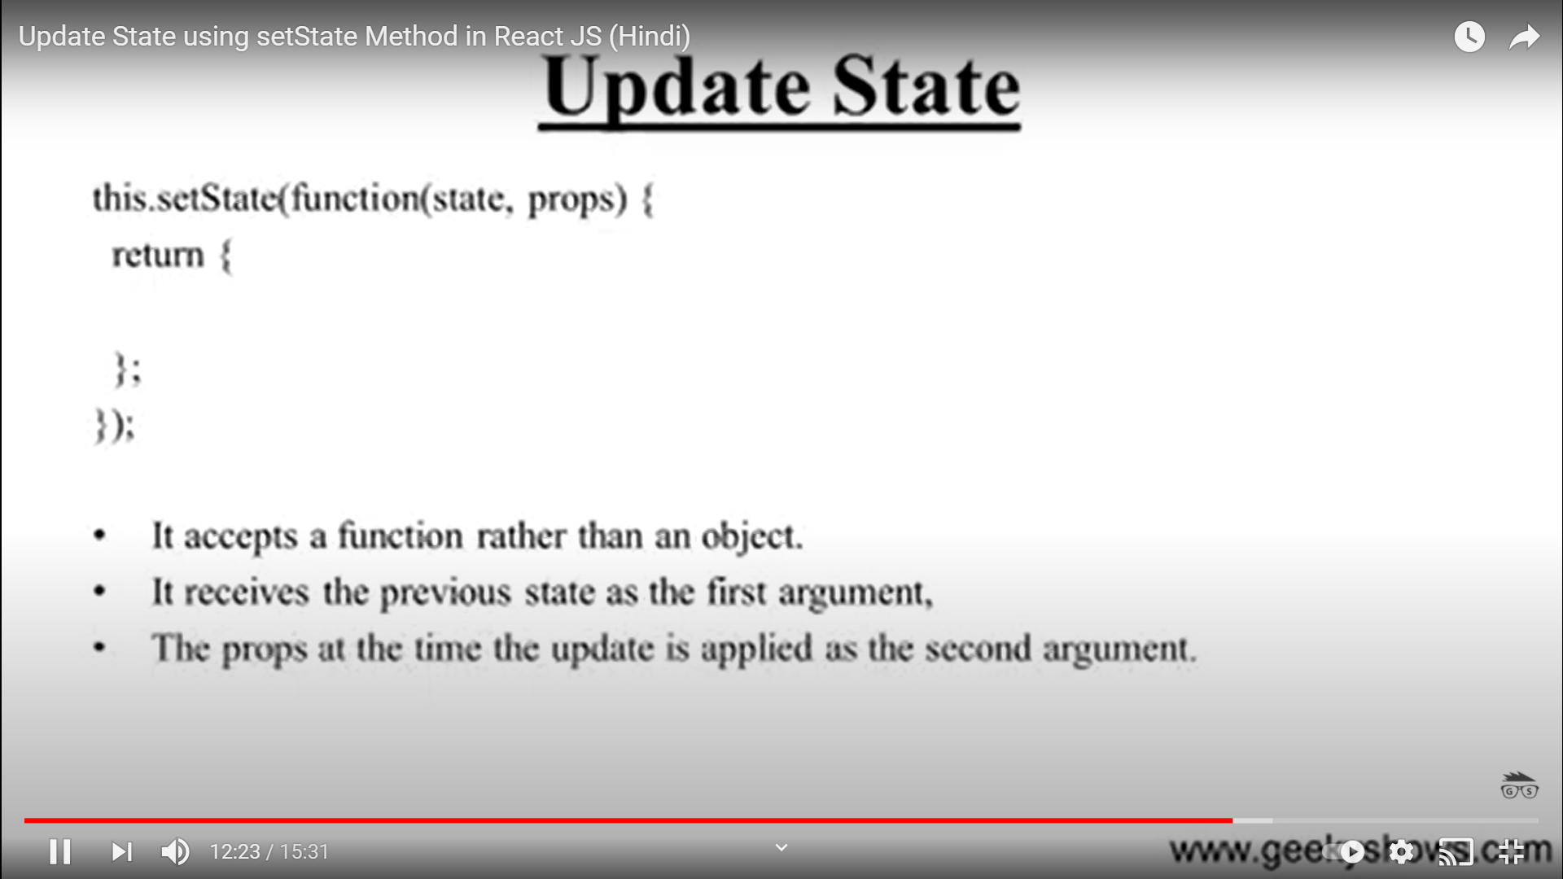

Demos

Event Component

import React from 'react';

import ReactDOM from 'react-dom';

class EventComp extends React.Component {

  shoot() {

    alert("Great Shot!");

  }

  render() {

    return (

      <button onClick={this.shoot}>Take the shot!</button>

    );

  }

}

export default EventComp;

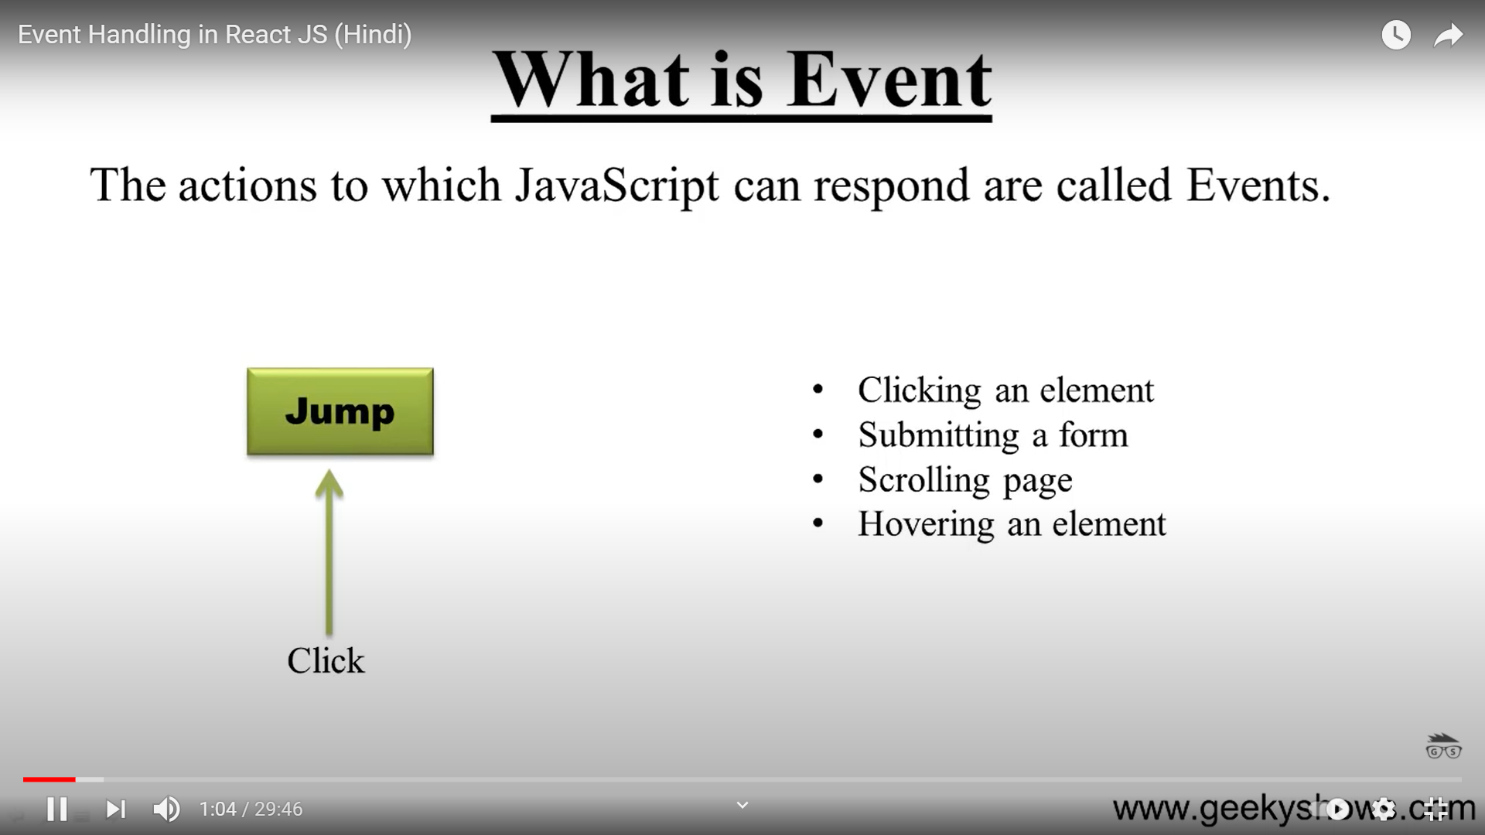

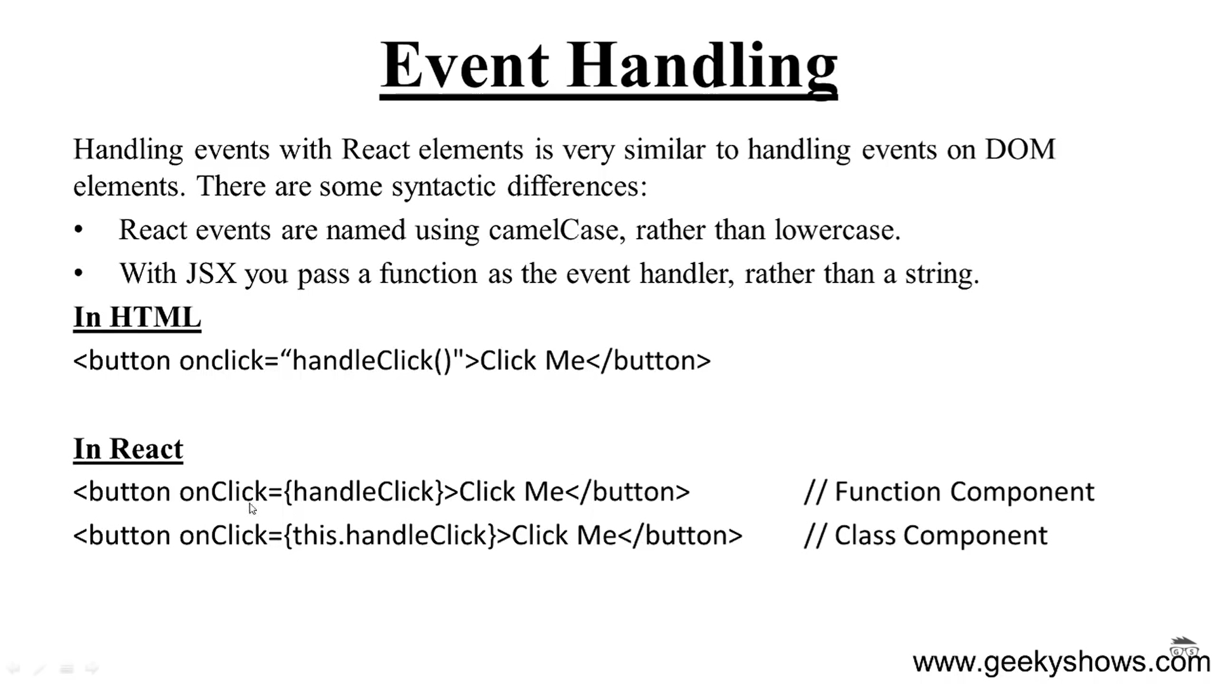

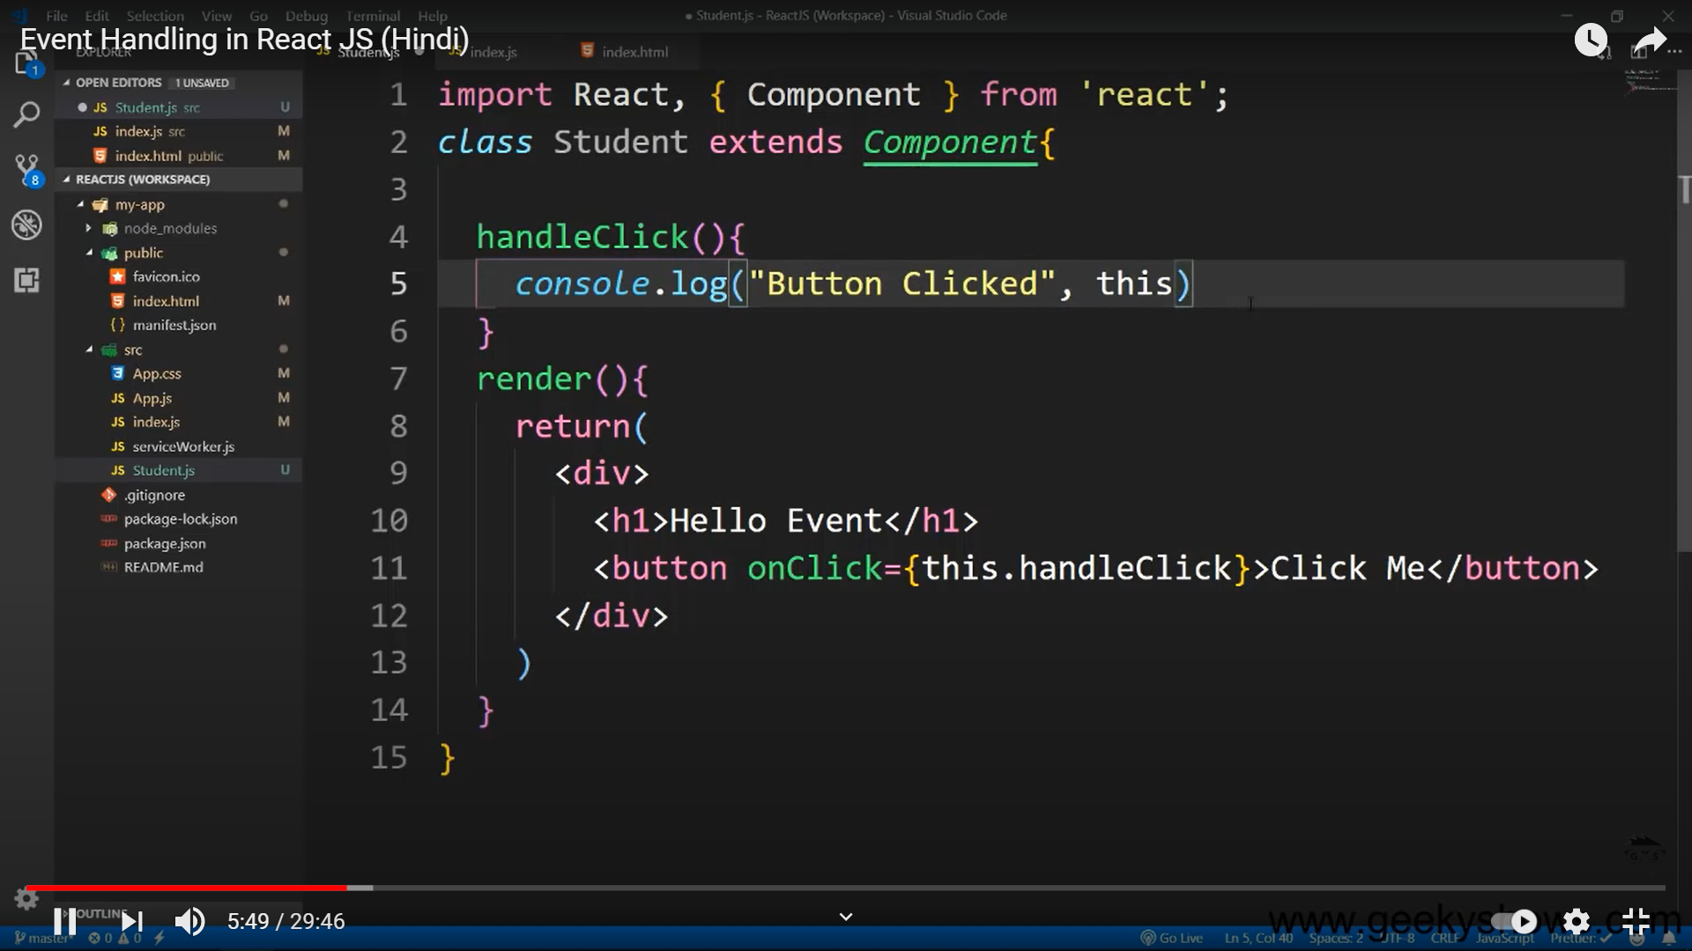

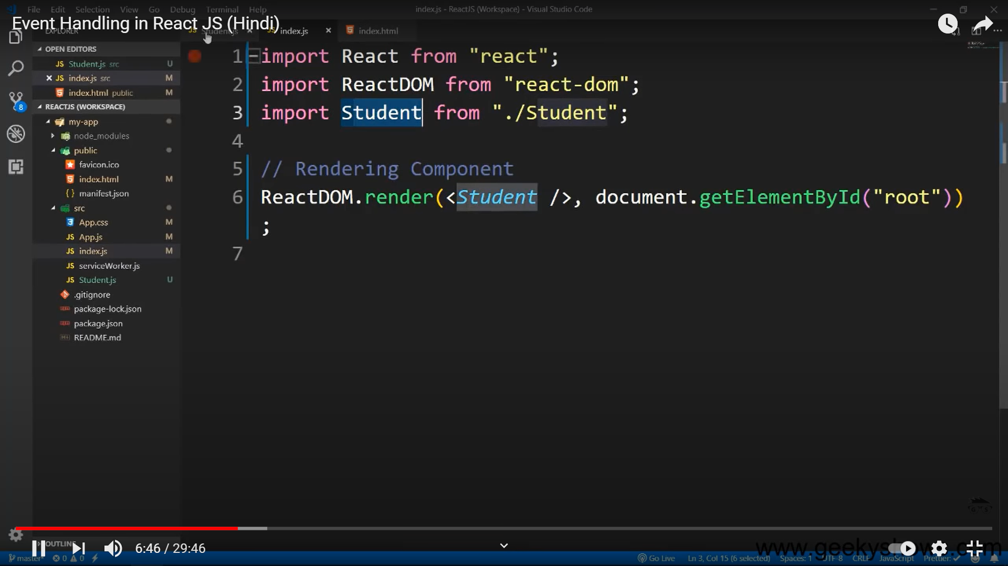

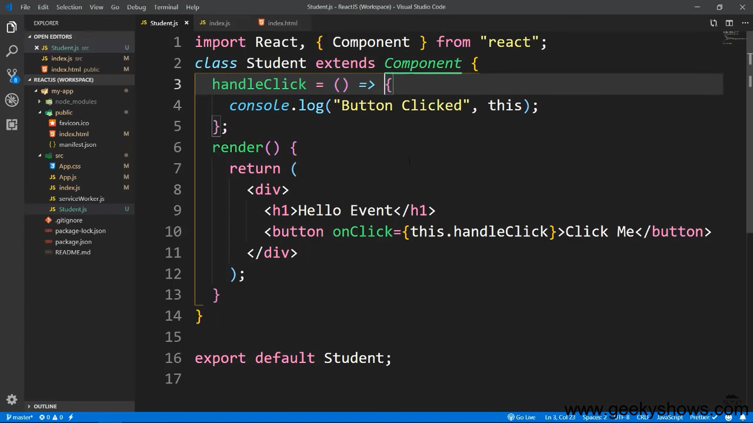

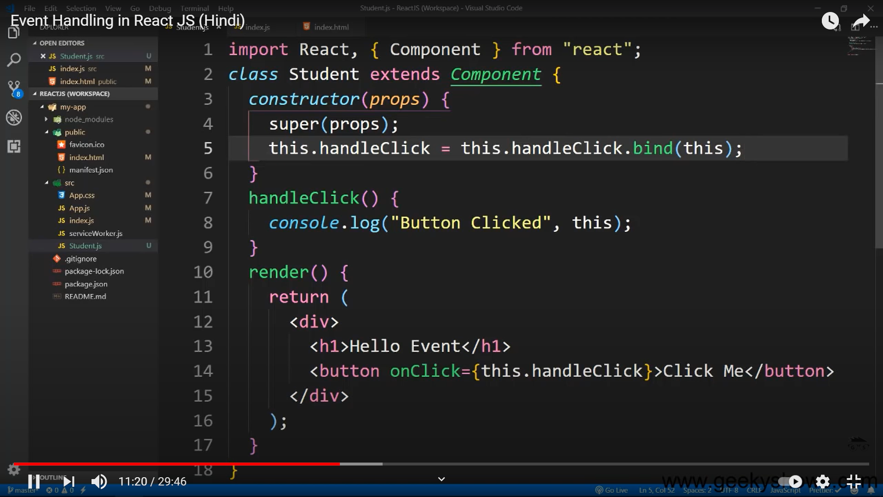

<https://reactjs.org/docs/handling-events.html>

Event Handling

props

<https://itnext.io/what-is-props-and-how-to-use-it-in-react-da307f500da0>

<https://reactjs.org/docs/components-and-props.html#:~:text=Function%20and%20Class%20Components&text=This%20function%20is%20a%20valid,they%20are%20literally%20JavaScript%20functions>.